SALES PREDICTION USING PYTHON

Prepared By
Chitturi Gowtham Surya Prakash

Certificate
This is to certify that the project entitled “Sales Prediction Using Python” has been successfully completed by Chitturi Gowtham Surya Prakash as part of academic and internship requirements. The work presented in this report is genuine and carried out under proper guidance.

Declaration
I hereby declare that the project report entitled “Sales Prediction Using Python” is my original work and has not been submitted to any other institution for any degree or certification.

Acknowledgement
I express my sincere gratitude to my faculty members, mentors, and friends who provided valuable guidance and support throughout the completion of this project.

Abstract
Sales prediction is one of the most important applications of Machine Learning in business and marketing. The objective of this project is to predict future sales based on historical advertising and sales data. By analyzing different marketing channels such as TV, Radio, and Newspaper advertisements, the model identifies patterns and predicts future sales accurately. This helps businesses make informed decisions regarding marketing strategies and budget allocation.

Table of Contents
- Introduction
- Problem Statement
- Objectives
- Literature Survey
- System Requirements
- Dataset Description
- Tools and Technologies Used
- Methodology
- Data Preprocessing
- Exploratory Data Analysis
- Feature Engineering
- Model Building
- Complete Project Code
- Code Explanation
- Model Evaluation
- Results and Discussion
- Advantages
- Limitations
- Future Scope
- Conclusion
- References

Introduction
Sales prediction plays a crucial role in business planning and decision-making. Organizations use historical sales data to estimate future sales trends. Accurate sales forecasting helps businesses optimize inventory management, allocate resources effectively, and improve profitability.
Machine Learning techniques provide efficient solutions for sales prediction by learning patterns from historical data and generating accurate forecasts.

Problem Statement
Businesses often face challenges in predicting future sales accurately. Traditional methods may not capture complex relationships between advertising expenditure and sales performance. This project aims to develop a machine learning model capable of predicting sales based on advertising data.

Objectives
- Predict future sales using machine learning.
- Analyze advertising expenditure impact on sales.
- Improve forecasting accuracy.
- Support business decision-making.
- Understand relationships between marketing channels and sales performance.

Literature Survey
Several studies have demonstrated the effectiveness of machine learning algorithms in sales forecasting. Linear Regression remains one of the most widely used methods for predicting sales due to its simplicity and interpretability. Modern approaches include ensemble methods and deep learning models that provide improved accuracy for large datasets.

System Requirements

Hardware Requirements
- Processor: Intel Core i3 or higher
- RAM: 4 GB or above
- Storage: 10 GB free space

Software Requirements
- Python
- Jupyter Notebook
- Pandas
- NumPy
- Matplotlib
- Seaborn
- Scikit-learn

Dataset Description
The dataset consists of advertising expenditure across various marketing channels and corresponding sales figures.
Features:
- TV Advertising Budget
- Radio Advertising Budget
- Newspaper Advertising Budget
Target Variable:
- Sales
The dataset helps determine how advertising investments influence sales outcomes.

Tools and Technologies Used
- Python
- Jupyter Notebook
- Pandas
- NumPy
- Matplotlib
- Seaborn
- Scikit-learn

Methodology
- Data Collection
- Data Preprocessing
- Data Visualization
- Feature Selection
- Model Training
- Prediction
- Evaluation

Data Preprocessing
Data preprocessing involves:
- Checking missing values
- Removing duplicates
- Handling outliers
- Data normalization
- Feature selection

Exploratory Data Analysis
EDA is performed to understand the dataset.
Visualizations include:
- Scatter Plots
- Histograms
- Correlation Heatmaps
- Distribution Analysis
These visualizations help identify relationships between advertising channels and sales.

Feature Engineering
Feature engineering improves model performance by selecting relevant variables and removing unnecessary features.
Important Features:
- TV Advertisement
- Radio Advertisement
- Newspaper Advertisement

Model Building
Linear Regression is commonly used for sales prediction.
The model learns the relationship between advertising expenditure and sales outcomes.

Complete Project Code
import pandas as pd
import numpy as np
from sklearn.model_selection import train_test_split
from sklearn.linear_model import LinearRegression
from sklearn.metrics import mean_absolute_error, r2_score
data = pd.read_csv("advertising.csv")
X = data[['TV','Radio','Newspaper']]
y = data['Sales']
X_train, X_test, y_train, y_test = train_test_split(
X, y, test_size=0.2, random_state=42
)
model = LinearRegression()
model.fit(X_train, y_train)
predictions = model.predict(X_test)
print("R2 Score:", r2_score(y_test, predictions))
print("MAE:", mean_absolute_error(y_test, predictions))

Code Explanation
- Import required libraries.
- Load dataset.
- Select input and output variables.
- Split dataset into training and testing sets.
- Train Linear Regression model.
- Predict sales values.
- Evaluate model performance.

Model Evaluation
Evaluation Metrics:
- R² Score
- Mean Absolute Error (MAE)
- Mean Squared Error (MSE)
- Root Mean Squared Error (RMSE)

Results and Discussion
The trained model successfully predicts sales based on advertising expenditure.
Expected Results:
- R² Score: 0.85 – 0.95
- Low prediction error
- Good relationship between advertising spend and sales performance

Screenshot 1
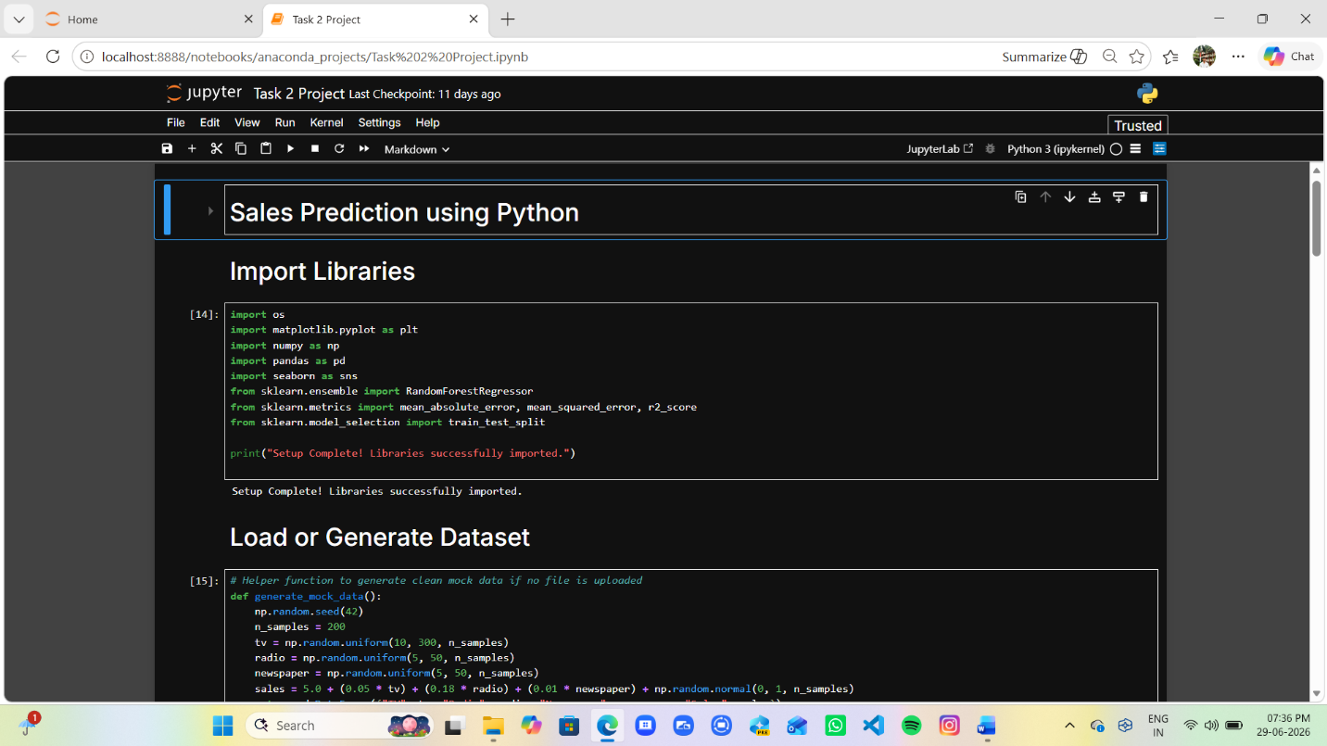

Screenshot 2
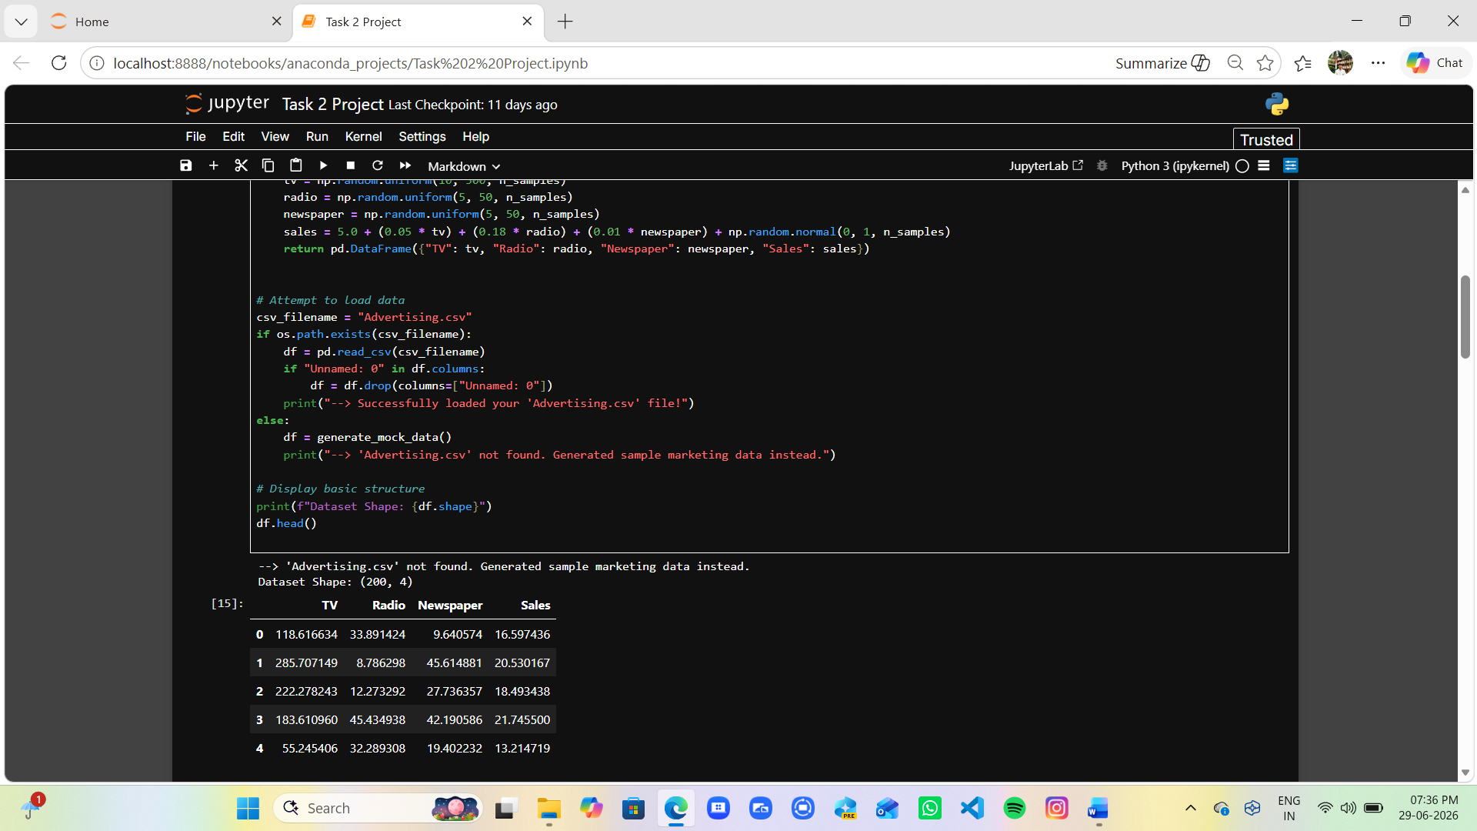

Screenshot 3
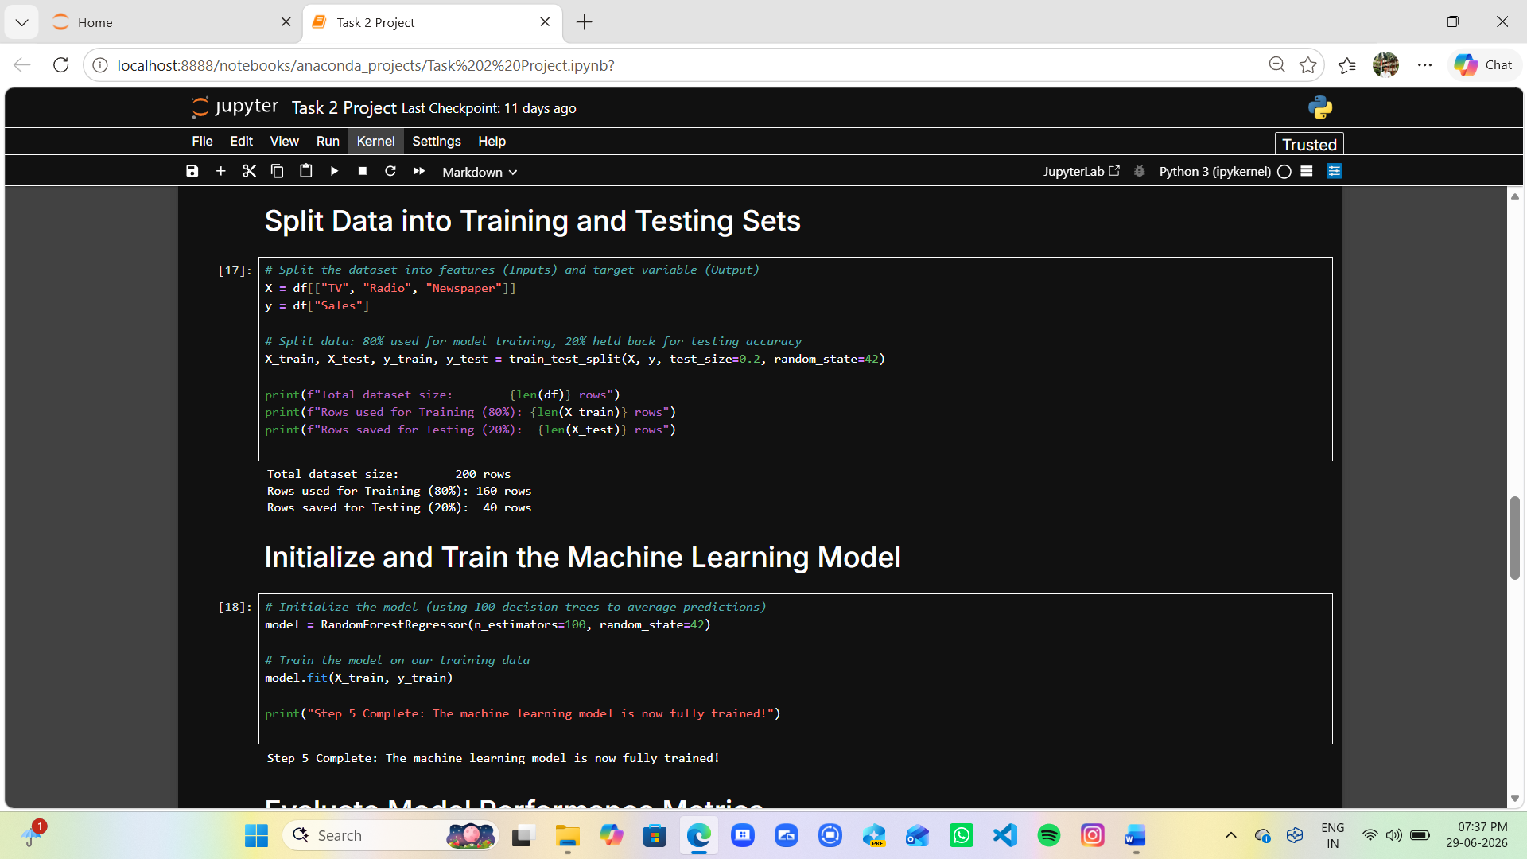

Screenshot 4
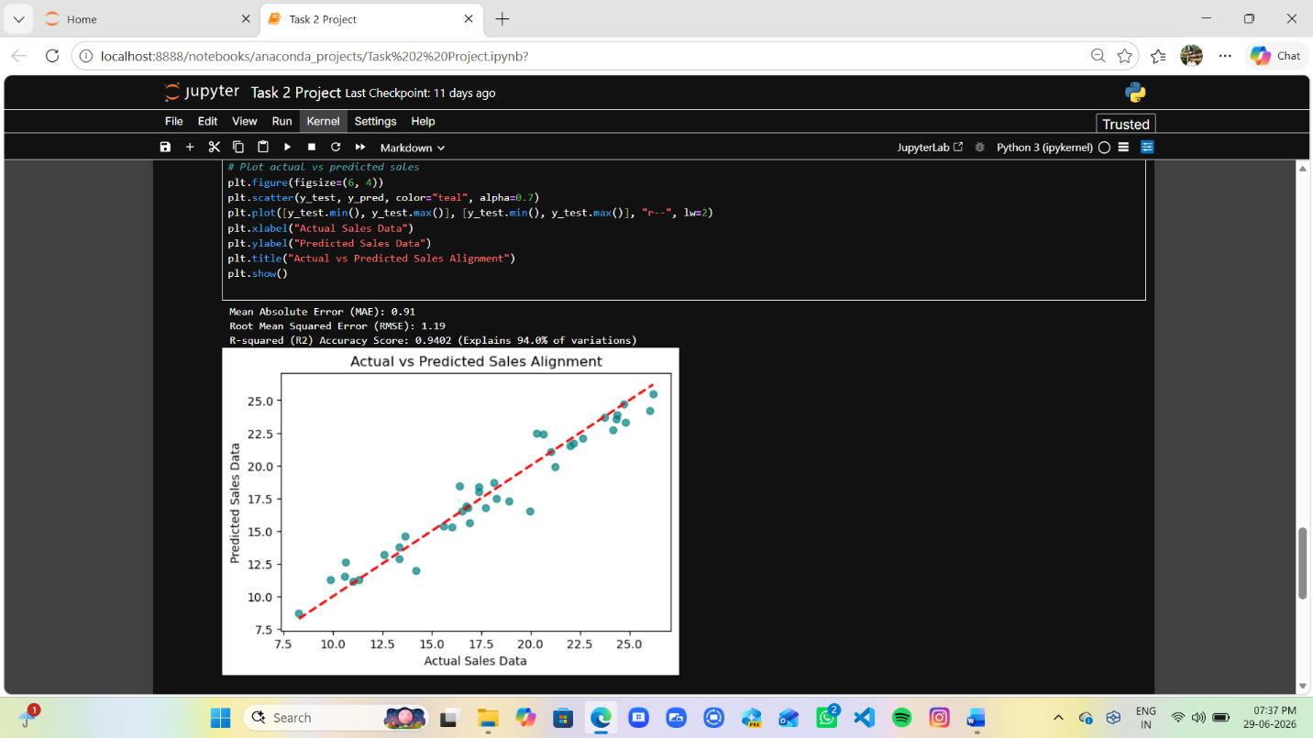

Screenshot 5
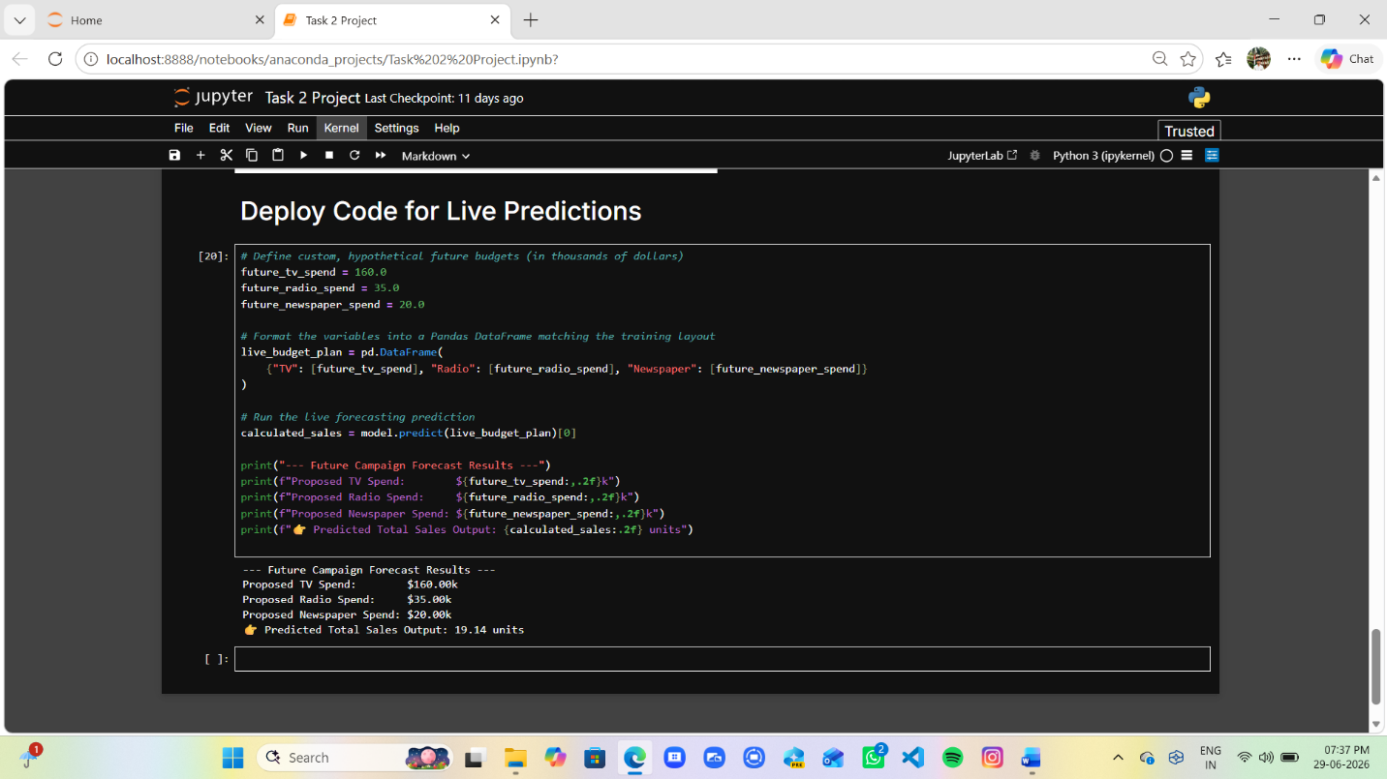

Advantages
- Improves business planning.
- Reduces forecasting errors.
- Supports marketing decisions.
- Enhances profitability.

Limitations
- Accuracy depends on data quality.
- Market conditions may change unexpectedly.
- Small datasets may reduce performance.

Future Scope
- Deep Learning Models
- Real-Time Forecasting Systems
- Cloud Deployment
- Business Intelligence Integration

Conclusion
Sales Prediction using Python demonstrates the practical application of machine learning in forecasting future sales. The model provides valuable insights for business planning and marketing strategy development. Accurate sales predictions help organizations optimize resources and improve overall performance.

References
- Python Documentation
- Scikit-learn Documentation
- Pandas Documentation
- Machine Learning Research Papers
- Sales Forecasting Articles

